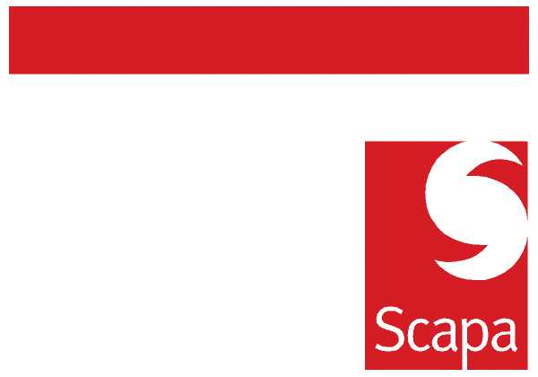

Announcement – Andreas Berginger

I am pleased to announce that, with immediate effect, Andreas Berginger is transferring from R&D to Operations as Production Manager.

He will report directly to me.

The local contact person in R&D on an interim basis is Marcel Wullschleger who reports to Dan Jeffrey.

I am sure you join me in wishing Andreas every success in his new position.

Sandro Pellegrino
General Manager - Rorschach

Date: 19 January 2010

